Case Study
SaaS Subscription & Churn
Problem Statement
The SaaS company is seeing revenue growth stall despite rising signups. Leadership suspects churn is the root cause but doesn't know which customer segments are most at risk or what's driving them to cancel.
Data Overview
2,000 customer subscription records covering plan type, acquisition source, signup and cancellation dates, MRR, and customer lifetime value across a 2-year period (2022–2023).
Questions:
- What's the overall monthly churn rate?
- Which subscription plan has the highest churn?
- What's the average customer lifetime (in months) before cancellation?
- Is churn higher for customers who signed up via a discount/trial vs. full price?
- What's the Monthly Recurring Revenue (MRR) trend over the last 12 months?
- Which customer segment (by plan or signup cohort) has the best retention?

Data Cleaning (Excel)
- Verified no duplicate CustomerIDs across 2,000 records
- Formatted SignupDate and CancelDate columns as proper date types — CancelDate intentionally blank for active customers, not a data error
- Added ChurnFlag column (=IF(Status="Churned",1,0)) and TotalRevenue column for pivot analysis
- Pivot check confirmed plan distribution: ~50% Basic, ~35% Pro, ~15% Enterprise
Analysis (SQL)
Ran 6 queries covering: overall churn rate, churn by plan, average tenure and LTV by plan, discount vs full-price churn comparison, MRR trend, and retention by acquisition source.
Key Findings
- What's the overall monthly churn rate?
Overall churn rate is 29.55% — meaning roughly 1 in 591 customers cancel each month.
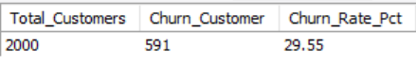
- Which subscription plan has the highest churn?
Basic plan has the highest churn at 30.92% vs Enterprise at 8.68% — price sensitivity and lower perceived value are likely drivers.
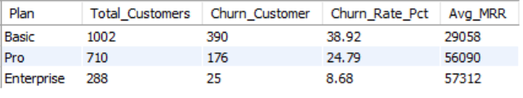
- What's the average customer lifetime (in months) before cancellation?
Average customer lifetime before cancellation is only 9.21 months on Basic vs 10.28 months on Enterprise — a major LTV gap. Customers across all plans cancel within a similar window — between 9.2 and 10.3 months — but the revenue impact of losing an Enterprise customer (₹2,045) is 7.6x higher than losing a Basic customer (₹267). This means churn is not just a volume problem — it's a value problem
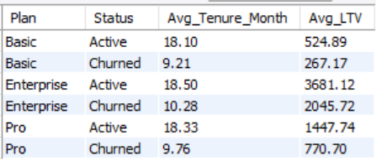
- Is churn higher for customers who signed up via a discount/trial vs. full price?
Customers acquired via Free Trial/Discount churn at 27.27% vs 29.96% for Full-Price — It suggests the trial experience is doing a good job of attracting genuinely interested customers — the bigger retention problem lies with full-price customers whose expectations may not be met after paying full price from day one.
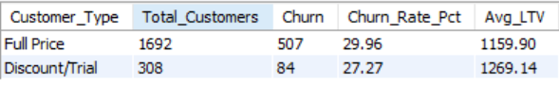

- What's the Monthly Recurring Revenue (MRR) trend over the last 12 months?
Direct Sales acquisition channel has the best retention rate at 33.33% and highest average LTV — worth increasing investment here.
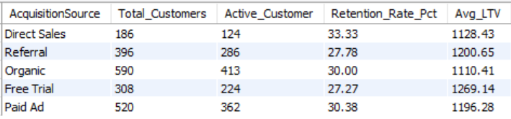

- What's the Monthly Recurring Revenue (MRR) trend over the last 12 months?
MRR has been growing steadily since January 2022, reaching a cumulative MRR of 142,460 by January 2024. Monthly new MRR generally increased over time, with particularly strong months such as January 2023 (7,606 MRR) and December 2023 (7,246 MRR). However, the sharp drop in January 2024 (199 MRR) appears to represent incomplete monthly data rather than an actual decline.

Dashboard (Power BI)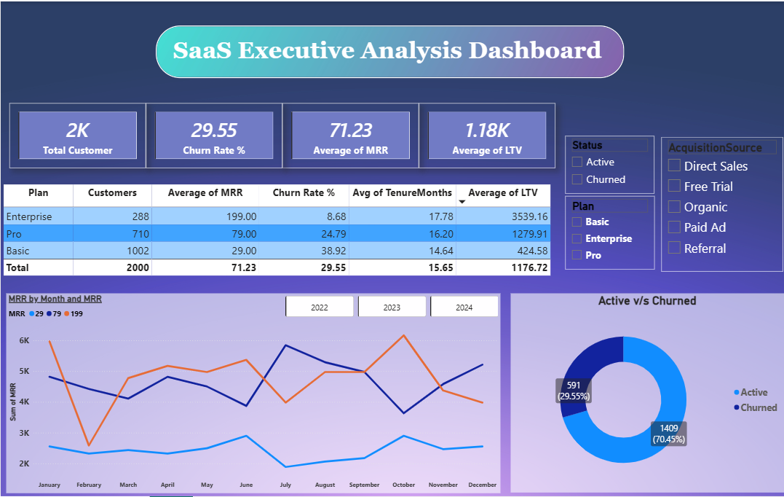
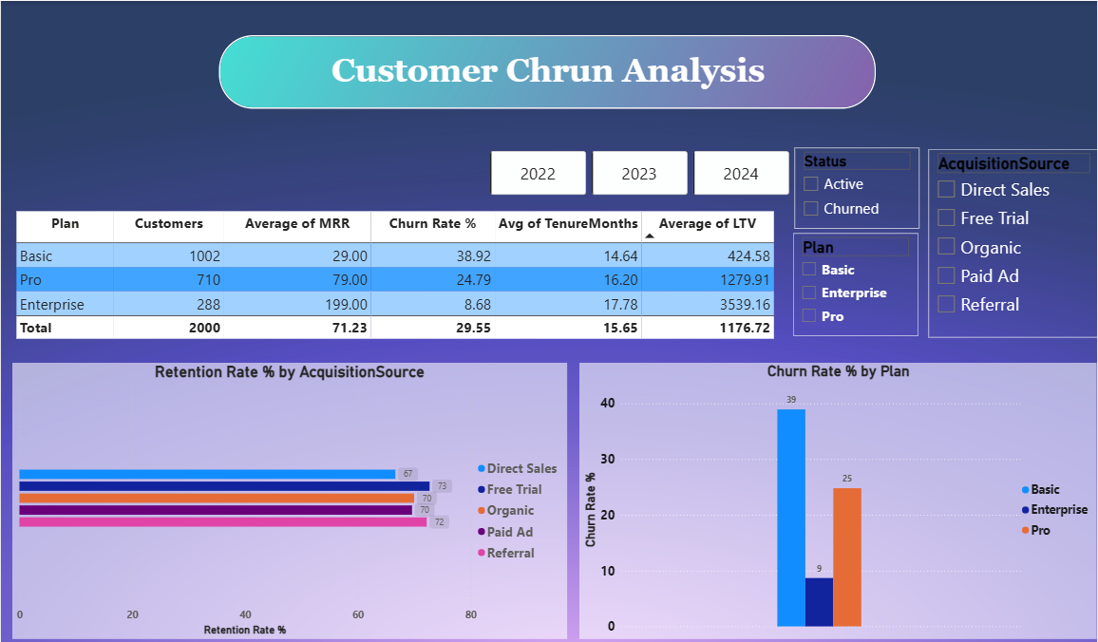
Recommendations.
- Focus on the Basic plan first. It has the highest churn rate (30.92%) and also has the most customers. Improving this plan can have the biggest impact on revenue. Add a simple onboarding guide and send a follow-up email after 30 days to help new customers get started.
- Encourage Basic users to upgrade to Pro. Offer a limited-time discount or extra features within the first 60 days. This can help customers see more value and stay longer.
- Invest more in the Direct Sales channel. Customers from this channel stay longer and spend more over time. Bringing in more customers this way can improve long-term revenue.
- Find customers before they leave. If a Basic plan customer hasn't logged in for 14 days, send them a reminder email or offer help. A small action at the right time can prevent cancellations.
- Offer an annual subscription plan. Paying for a full year can encourage customers to stay longer and reduce monthly cancellations while giving the business more predictable revenue.
Tool stack:
Excel (cleaning) → SQL (analysis) → Power BI (dashboard)

